#### Homework 4

#### Problem 1:

t = 0:0.1:10; % Time values from 0 to 10 seconds with a step of 0.1 seconds

v = 9.8 * t + 50; % Calculate the velocity using the given equation

figure; % Create the plot

plot(t, v, 'b-', 'LineWidth', 2); % Plot the velocity as a function of time

xlabel('Time (s)');

ylabel('Velocity (m/s)');

title('Velocity vs. Time');

grid on; % Add grid

ylim([0, max(v) + 5]); % Change vertical scale to start from zero and added 5 to the upper limit

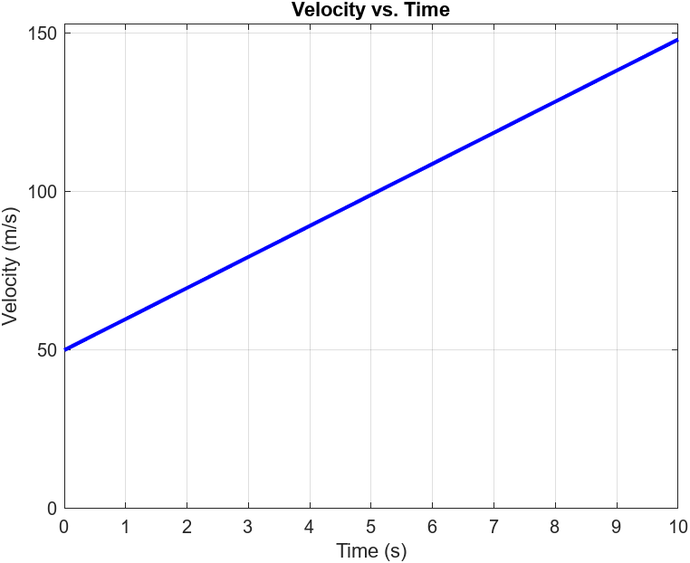

#### Problem 2:

t = 0:0.1:8; % Time values from 0 to 8 seconds with a step of 0.1 seconds

v = -9.8 * t + 50; % Calculate the velocity using the given equation

figure; % Create the plot

plot(t, v, 'b-', 'LineWidth', 2); % Plot the velocity as a function of time

xlabel('Time (s)');

ylabel('Velocity (m/s)');

title('Velocity vs. Time');

grid on; % Add grid

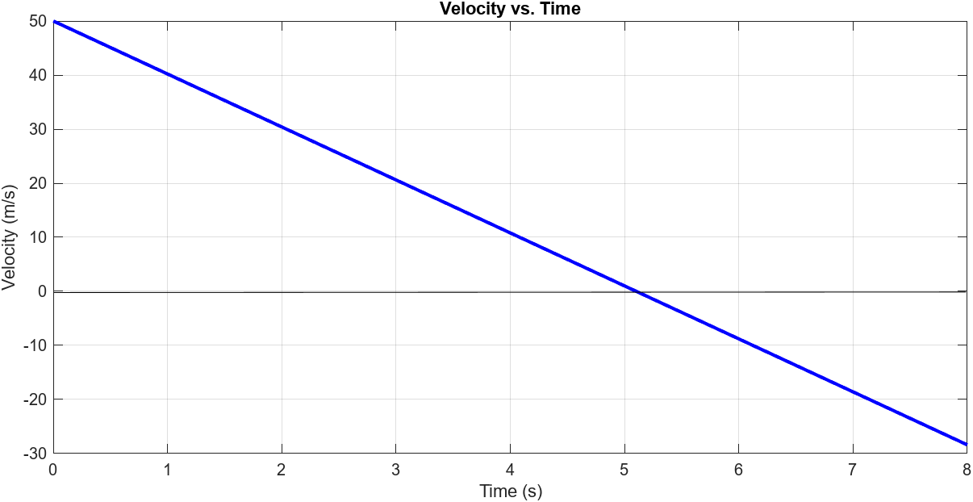

#### Problem 3:

v1 = 0:0.1:10; % Voltage values from 0 to 10 Volts with a step of 0.1 Volts

V3 = 0.1 * v1.^2 + 5; % Calculate the output Voltage using the given equation

figure; % Create the plot

plot(v1, V3, 'b-', 'LineWidth', 2); % Plot the output Voltage as a function of input voltage

xlabel('Input Voltage (V)');

ylabel('Output Voltage (V)');

title('Output Voltage vs. Input Voltage');

grid on; % Add grid

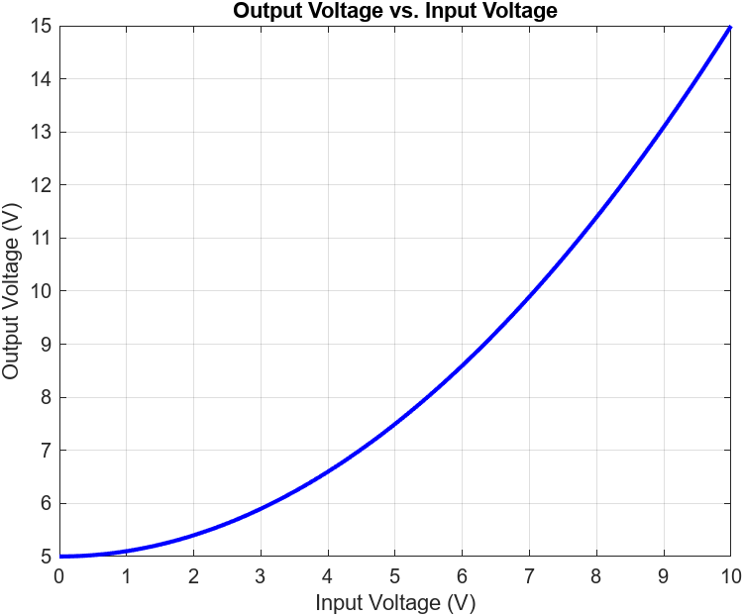

#### Problem 4:

x = logspace(log10(0.01), log10(100), 100); % Logarithmically spaced values from 0.01 to 100

% Calculate the corresponding y values

y = sqrt(x);

% Create the log-log plot

figure;

loglog(x, y, 'b-', 'LineWidth', 2);

xlabel('x');

ylabel('y = \surd x');

title('Log-Log Plot of y = \surd x');

grid on;

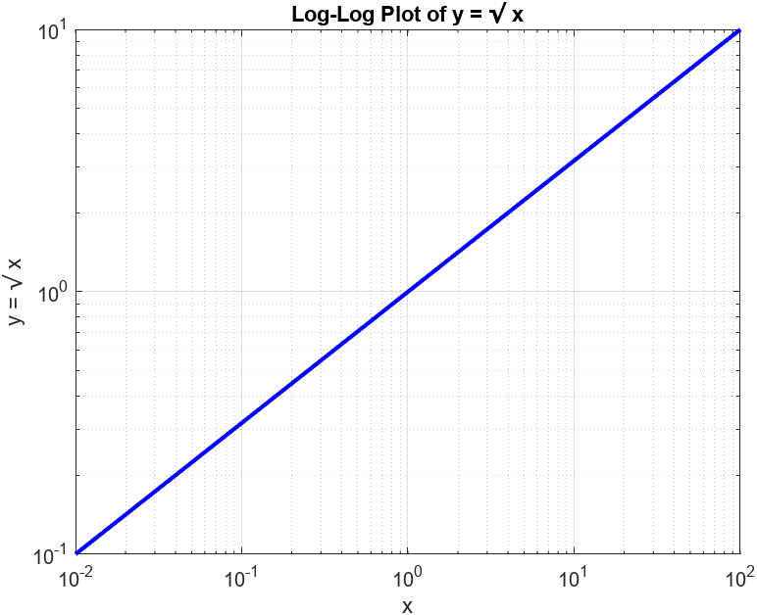

#### Problem 5:

x = logspace(log10(0.1), log10(10), 100); % Logarithmically spaced values from 0.1 to 10

% Calculate the corresponding y values

y = 2 * x.^3;

% Create the log-log plot

figure;

loglog(x, y, 'r-', 'LineWidth', 2);

xlabel('x');

ylabel('y = 2x^3');

title('Log-Log Plot of y = 2x^3');

grid on;

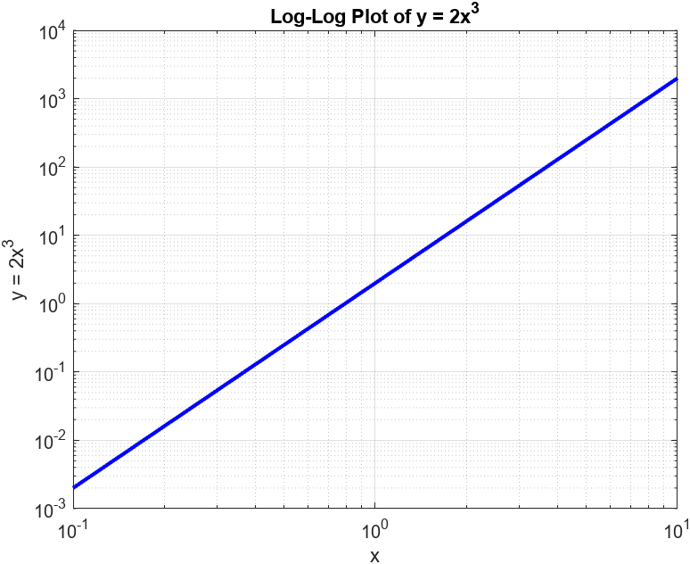

#### Problem 6:

years = [1995, 1996, 1997, 1998, 1999, 2000, 2001, 2002];

enrollment = [320, 330, 369, 350, 310, 370, 390, 400];

% Create a bar graph

figure;

bar(years, enrollment, 'b');

xlabel('Year');

ylabel('Student Enrollment');

title('College Program Enrollment Trend Since 1995');

grid on;

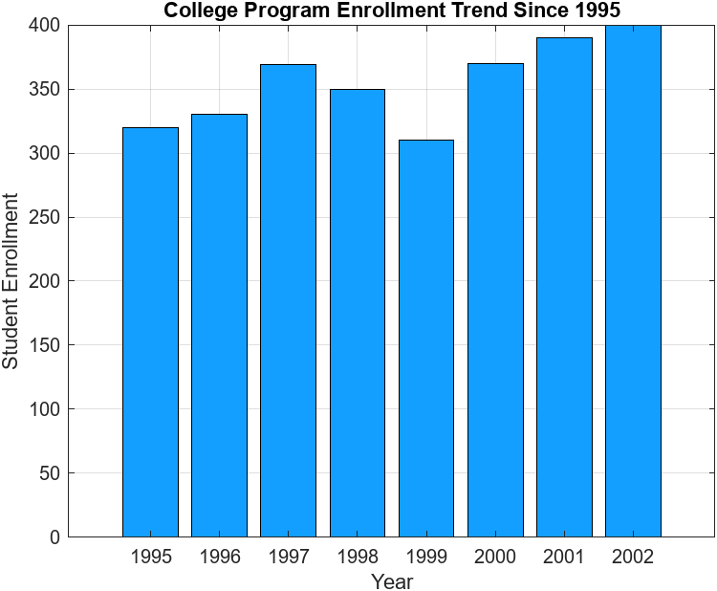

#### Problem 7:

years = [1995, 1996, 1997, 1998, 1999, 2000, 2001, 2002];

enrollment = [320, 330, 369, 350, 310, 370, 390, 400];

% Create a bar graph

figure;

stem(years, enrollment, 'b', 'filled');

xlabel('Year');

ylabel('Student Enrollment');

title('College Program Enrollment Trend Since 1995');

grid on;

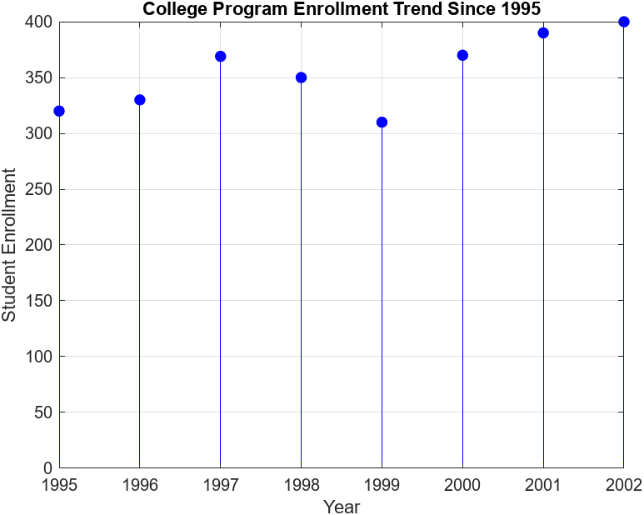

#### Problem 8:

a = 10; b = 1; c = 0.3;

t = 0:(0.01*pi):(2*pi); % Time values from 0 to 2 pi seconds with a step of 0.01 pi

x = cos(t).*( sqrt(b.^2-c.^2 .* (cos(a.*t)).^2 ) );

y = sin(t).*( sqrt(b.^2-c.^2 .* (cos(a.*t)).^2 ) );

z = c .* cos(a.*t);

% Create a 3D plot

figure;

plot3(x, y, z, 'b-', 'LineWidth', 2);

xlabel('X');

ylabel('Y');

zlabel('Z');

title('3D Curve');

grid on;

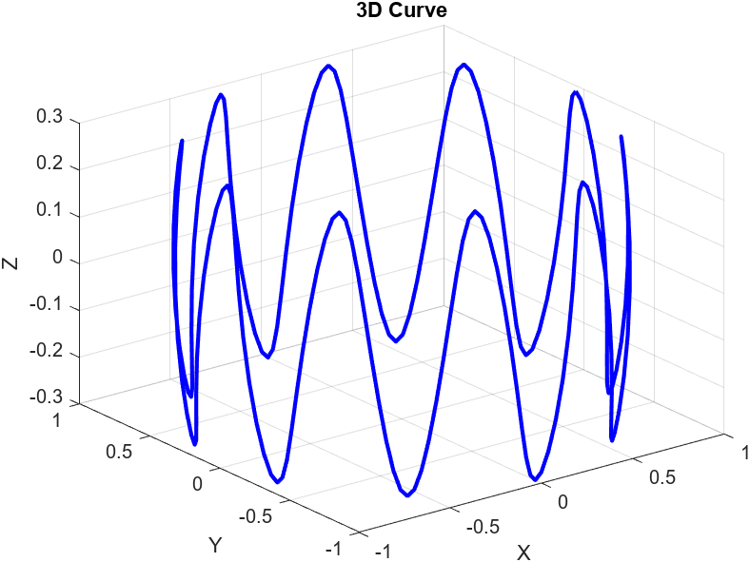

#### Problem 9:

c = 0.5;

u = (-pi):(0.01*pi):(pi);

v = (0):(0.01*pi):(pi);

[x, y] = meshgrid(u, v);

X = (c + cos(y)) .* cos(x);

Y = (c + cos(y)) .* sin(x);

Z = sin(y) .* cos(y);

% Create a 3D surface plot

figure;

surf(X, Y, Z);

xlabel('X');

ylabel('Y');

zlabel('Z');

title('3D Surface Plot');

colormap('parula'); % Set colormap for better visualization

colorbar; % Add colorbar to the plot

